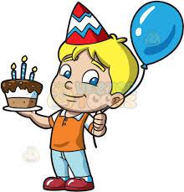 BOY’S BIRTHDAY THEMES

ROYAL THEME

KARATE PARTY THEME

SLIME THEME

SUPER HEROES THEME

MAD SCIENTIST THEME

MICKIE MOUSE THEME

PAW PATROL THEME

DISNEY THEME

LEGO MADNESS THEME

SPONGEBOB THEME

CARNIVAL THEME

BUZZ LIGHT YEAR THEME

SPORTS THEME

EGYPTIAN THEME

COWBOY THEME

FORTNITE THEME

Z00 THEME

HAWAIN THEME

POOL PARTY

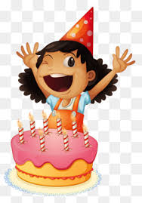

GIRL’S BIRTHDAY THEMES

BALLET THEME

MINNIE BOW-TIQUE THEME

PRINCESS THEME

SPA DAY THEME

CARNIVAL DAY THEME

UNDER THE SEA THEME

PIJAMA THEME

DISNEY THEME

ARABIC THEME

WINTER WONDERLAND THEME

GARDEN THEME

MAD SCIENTIST THEME

SLIME THEME

ALL PINK THEME

MAGIC THEME

EGYPTIAN THEME

MASQUERADE THEME

BEACH THEME/ POOL THEME

BABY SHOWER THEMES 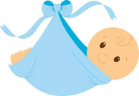

IT’S A BOY THEMES IT’S A GIRL THEMES

BEACH THEME BEACH THEME PINK

LITTLE KING THEME LITTLE PRINCESS THEME

MONSTER’S INC THEME DISNEY THEME

DISNEY THEME BABY BEAR PINK THEME

BABY BEAR THEME BUMBLE BEE THEME

ALL BLUE THEME ALL PINK THEME

LITTLE STAR BLUE THEME LITTLE STAR PINK THEME

BUMBLE BEE THEME LITTLE BALLERINA THEME

SPORTS THEME ZOO THEME

AHOY IT’S A BOY THEME MERMAID THEME

ARACADE THEME SPA DAY THEME

BLUE GARDEN THEME PINK GARDEN THEME

ELEPHANT THEME ALL FLOWER THEME

SPECIAL DELIVERY THEME SPECIAL DELIVERY PINK THEME

NO PINK ALLOWED THEME NO BLUE ALLOWED THEME

HEAVEN SENT THEME BLUE HEAVEN-SENT PINK OT WHITE THEME

READY TO POP BLUE THEME READY TO POP PINK THEME

WINTER WONDERLAND THEME WINTER WONDERLAND THEME

